RESOLUTION NO.__________

RE: CERTIFICATE OF APPROPRIATENESS UNDER THE
PROVISIONS OF THE ACT OF THE PENNSYLVANIA
LEGISLATURE 1961, JUNE 13, P.L. 282 (53
SECTION 8004) AND BETHLEHEM ORDINANCE NO.
3952 AS AMENDED.

WHEREAS, it is proposed to replace the existing wood and glass closure in the old garage door openings and install a new aluminum black frame and glass overhead paneled door at 217 Broadway.

NOW, THEREFORE, BE IT RESOLVED by the Council of the City of Bethlehem that a Certificate of Appropriateness is hereby granted for the work.

Sponsored by: (s)

(s)

ADOPTED BY COUNCIL THIS DAY OF

(s)
President of Council

ATTEST:

(s)
City Clerk

HISTORIC CONSERVATION COMMISSION

CASE # 417 – It is proposed to replace the existing wood and glass closure in the old garage door openings and install a new aluminum black frame and glass overhead paneled door at 217 Broadway.
OWNER/APPLICANT: Greg Salamoni / John T. Lee

The Commission upon motion by Mr. Evans and seconded by Mr. Cornish adopted the proposal that City Council issue a Certificate of Appropriateness for the proposed work described herein:

- The proposal to replace the existing wood and glass closure in the old garage door openings and install a new aluminum black frame and glass overhead paneled door at 217 Broadway was presented by John T. Lee and Greg Salamoni.

- The new door will fit the currently opening without any modification and will have 6 panels and 5 high.

- The door will have clear glass panels in flat black aluminum frames.

- The proposal was approved by a 6-2 motion.

- Those opposing the motion did so because they thought the aluminum and glass door was not historically appropriate for this well preserved, historically significant building design by A. W. Leh.

- Those voting in favor of the motion did so because the existing garage door infill was not original historic material, the door had been changed multiple times over the years, and they thought it important to support the new business and its needs.

- In a separate motion by Mr. Lader, seconded by Mr. Evans the Commission unanimously approved the use of steel or wood posts in the fence that was approved in April 2012.

CU: cu

By: 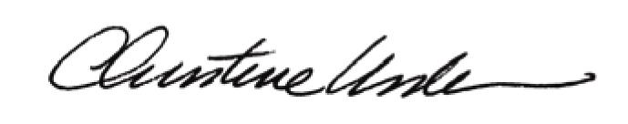

Date of Meeting: May 21, 2012 Title: Historic Officer

